Loanable Funds Market

Topic 1: Supply of and demand for loanable funds

Difficulty Level 1
- What causes firms to demand a higher quantity of loanable funds at a lower real interest rate?
  - The government offers subsidies to firms that borrow at lower interest rates
  - There is a higher rate of return on investments made at lower interest rates
  - There is a lower rate of return on investments made at lower interest rates
  - Firms only borrow funds at low interest rates
  - Banks cannot loan to firms at high interest rates
- The loanable funds model demonstrates the interaction of _______________________ in determining the equilibrium real interest rate.
Which of the following completes the sentence above?
  - households and firms
  - government and households
  - price level and output
  - savers and borrowers
  - foreign and domestic consumers

Difficulty Level 2
Use the graph below to answer the following questions. 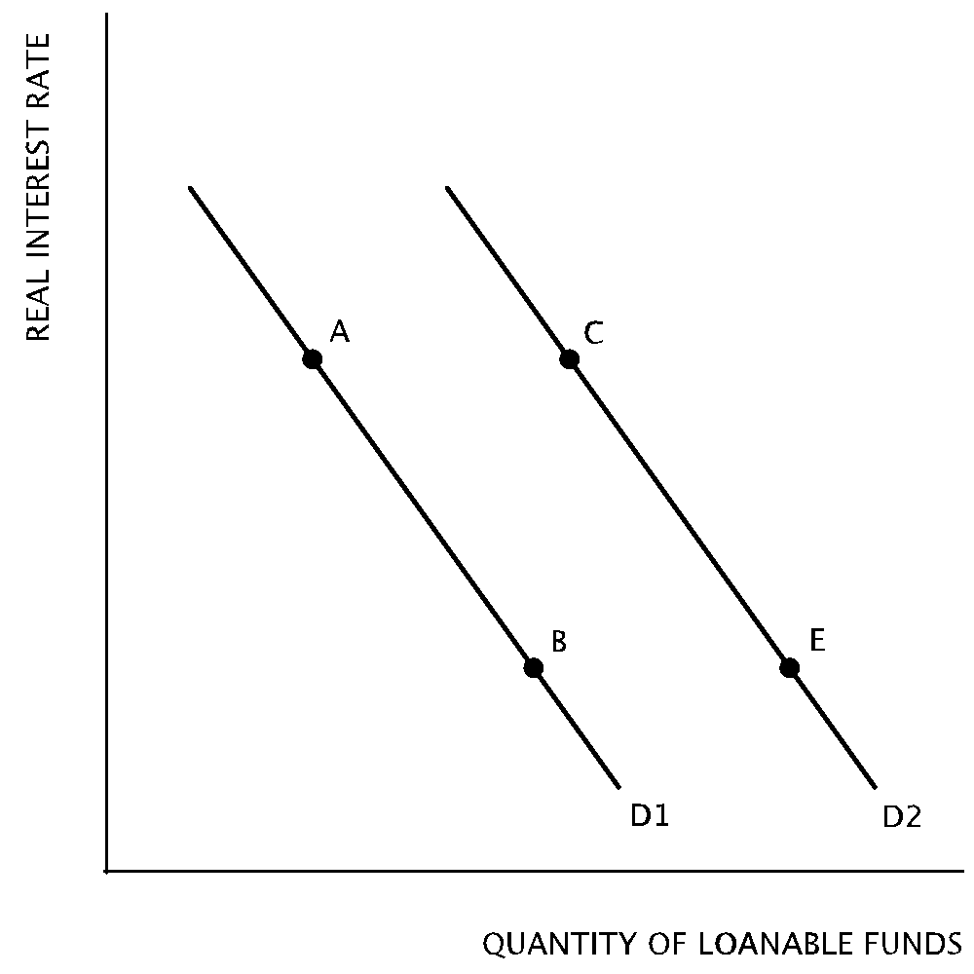

- Which of the following will most likely produce a movement from Point A on D1 to Point C on D2?
  - Corporate profits are expected to decline in the future
  - An increase in capital inflows from other nations
  - The federal government has a budget surplus
  - Households are encouraged to increase their savings
  - Firms become more optimistic about future business opportunities
- A movement from Point E on D2 to Point B on D1 will most likely be the result of
  - increased business opportunities after new computer technology is introduced.
  - a decrease in government spending that leads to a budget surplus.
  - a decrease in taxes that leads to a government budget deficit.
  - a decrease in private savings.
  - an increase in the marginal propensity to consume.
- Due to decreased confidence in the financial system, people have increased their savings in foreign financial institutions. What is the likely result on the domestic loanable funds market?
  - The demand for loanable funds will increase
  - The demand for loanable funds will decrease
  - The supply of loanable funds will increase
  - The supply of loanable funds will decrease
  - The domestic loanable funds market will be unaffected

Difficulty Level 3
- In the market for loanable funds, the equilibrium interest rate is 4% and the equilibrium quantity of loanable funds is $100 billion. What will be the likely result if financial institutions offer an interest rate of 6%?
  - There will be an increase in the quantity of loanable funds demanded.
  - There will be an increase in borrowing.
  - The quantity of loanable funds supplied will be more than $100 billion.
  - The quantity of loanable funds demanded will be greater than the quantity supplied.
  - The loanable funds market will remain in equilibrium.

Topic 2: Equilibrium real interest rate

Difficulty Level 2
- If firms believe that business opportunities will decrease in the future, the demand for loans and the real interest rate in the loanable funds market will likely change in which of the following ways in the short run?
Demand for Loans Real Interest Rate
  - Decrease Not change
  - Decrease Increase
  - Increase Increase
  - Increase Decrease
  - Decrease Decrease
Use the diagram below to answer the following questions.
- 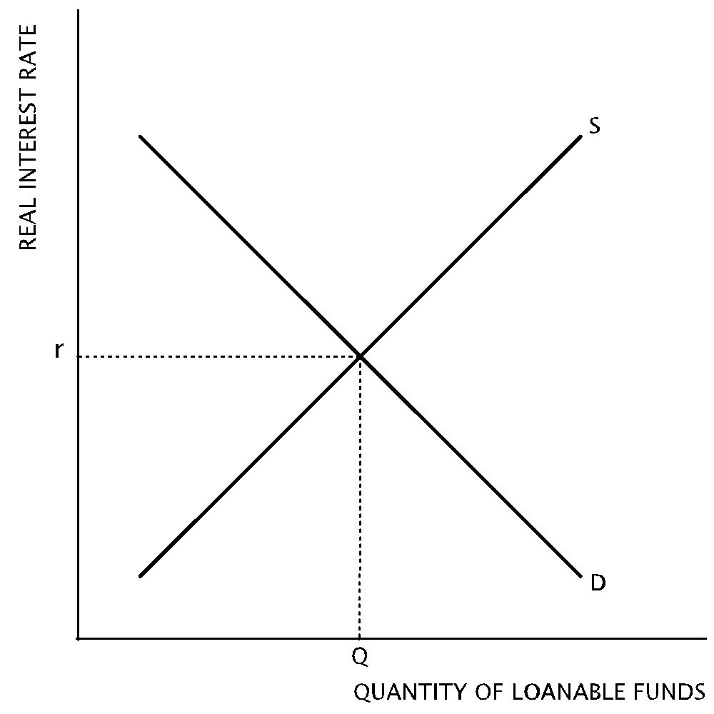According to the graph, an increase in savings by households will
  - increase the demand for loanable funds and increase the real interest rate
  - decrease the demand for loanable funds and decrease the real interest rate
  - increase the supply of loanable funds and decrease the real interest rate
  - decrease the supply of loanable funds and increase the real interest rate
  - not affect the loanable funds market
- Which of the following changes will cause an increase in the real interest rate in the loanable funds market?
  - The government launches a campaign to encourage the public to increase their savings.
  - Firms are optimistic about the housing market and increase construction projects
  - The national government reports its second consecutive annual budget surplus
  - Foreign savers increase their deposits in domestic financial institutions
  - The government increases the money supply

Topic 3: Crowding out

Difficulty Level 1
- Which of the following statements best describes crowding out?
  - An increase in the money supply.
  - An increase in net exports resulting from a depreciation of the currency.
  - An increase in private borrowing subsidized by the government.
  - A decrease in private investment resulting from government borrowing.
  - An increase in the supply of loanable funds due to increased public and private savings.
- Government borrowing causes crowding out because
  - lower interest rates increase private sector investment
  - higher interest rates decrease private sector investment
  - higher interest rates increase private sector investment
  - a larger money supply increases private sector investment
  - a smaller money supply decreases private sector investment

Difficulty Level 2
- The national government has increased deficit spending on goods and services. In the long-run, which of the following changes would most likely result from this policy?
Real Interest Rate Investment
1 | B | 6 | C | 11
2 | D | 7 | E | 12
3 | E | 8 | C | 13
4 | B | 9 | B | 14
5 | D | 10 |  | 15

  - Decrease Increase
  - Decrease Decrease
  - No change Increase
  - Increase Decrease
  - Increase No change
- Which of the following changes will most likely result in crowding out?
  - Increase in trade deficit
  - Increase in labor productivity
  - Decrease in government spending
  - Increase in budget deficit
  - Decrease in commodity prices
- Expansionary fiscal policies adopted to counteract a recession tend to result in
  - less public spending
  - lower prices
  - a high rate of economic growth
  - higher interest rates
  - decreased investment by foreign companies

